**Chua Li Chu**

Ah Chu • Li Chu • Chu • Shi Shi

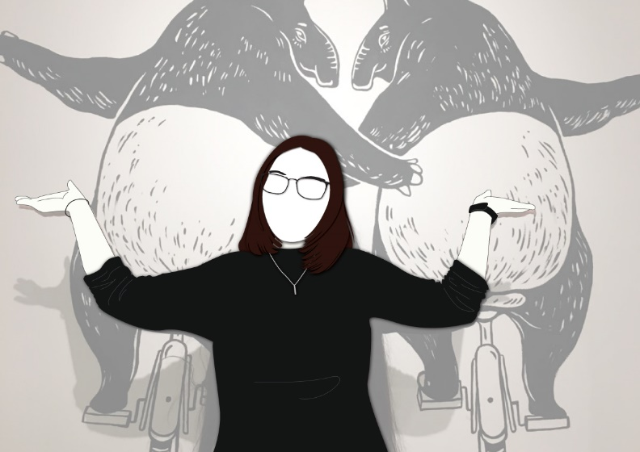

# **Biodata**

Address : PT 12701, Taman Bukit Payung Utama, Pekan Bukit Payung, 21400 Marang Terengganu.

Phone no. : 0109242528

Email : [chualichu@gmail.com](mailto:chualichu@gmail.com)

Social Media : <https://www.instagram.com/lichu_kira>

# **Education**

## New Era University College

Bachelor’s Degree in Visual Communication(2018 - Present)

## New Era University College

Diploma in Graphic Design (2014 - 2017)

SMK Chung Hwa Wei Sin, Kuala Terengganu

Sijil Pelajaran Malaysia (2008 - 2013)

# **Professional experiences**

## Q-dees Pegasus Kuala Terengganu

### Assistance Teacher, Designer 2017 Aug – 2018 Aug

Assist Teacher and Design for School.

## **Industrial Training**

## One Biz Online Sdn Bhd.

### Graphic Designer Internship 2016 Nov – 2017 Feb

In-house Graphic Design internship.

## **Community involvement**

### 2012 Dec Vice-Battalion Commander

Buddhist Learning Camps | Terengganu Buddhist Association

### 2017 Sept Photographer

### Infinity 14th Art & Design Autumn Graduation Showcase | New Era University College Art and Design Autumn Graduation Showcase

### 2018 May Fund Card Design

### 2018 Wesak Day | Terengganu Buddhist Association

### 2019 May Fund Card Design

### 2019 Wesak Day | Terengganu Buddhist Association

### 2019 June Art and Publicity Organizer

2019 I-DO Music Club Bazaar | New Era University College I-DO Music Club

### **Commissioned Projects**

### 2018 Graphic Designer

re.mote | T-shirt Design and Poster Design

### 2018 Nov Music Editor

Q-dees Annual Concert | Q-dees Pegasus Kuala Terengganu

### **Participated Exhibitions**

2017 Sept Infinity 14th Art & Design Autumn Graduation Showcase

New Era University College Art and Design Autumn Graduation Showcase

2018 Feb Made In Batu 11 Memorabilia Photo Wall

The Department of Art and Dsign New Era University College.

**Prize**

2017Sept Awarded Book Prize in Diploma in Graphic Design 2017

New Era University College

# **Skills**

* Adobe Photoshop
* Adobe Illustrator
* Adobe In-design
* Adobe After Effect
* Adobe Premier Pro
* Adobe Audition
* Photography

**Referees**

Ms. Chua Ming Chu Headmistress of Q-dees Pegasus Kuala Terengganu,

0102311513, qdeesktrg@gmail.com